**Makerfabs UWB AT Module AT Command Manual**

**V1.0.5**

Author：Vincent

Time：2023/10/13

|  |  |  |  |
| --- | --- | --- | --- |
| **日期Date** | **版本** | **版本描述** | **作者** |
| 20230815 | v1.0.0 | 使用介绍&功能介绍 | Jerry |
| 20230823 | V1.0.1 | 1. 修改笔误 2. Anchor&Tag软件融合 3. 完善Run Led引脚说明 4. 完善Tx Led引脚说明 5. 完善Rx Led引脚说明 6. 完善UART2 RX/RESET/WAKEUP引脚说明 | Jerry |
| 20230829 | V1.0.2 | 1. 增加850K速率 2. 增加信号强度 3. 修改开机日志 4. 修改命令，AT+SETCFG 5. 修改命令，AT+GETCFG? 6. 修改命令，AT+RANGE | Jerry |
| 20230926 | V1.0.3 | 1. 完善文档 2. 增加硬件应用电路 | Jerry |
| 20230926 | V1.0.4 | 1. 增加封装尺寸图 | Jerry |
| 20231013 | V1.0.5 | 翻译初版 | Vincent |

目录

一 手册简介 5

1.1 Introduction 5

1.2 Feature 5

1.3 Functional block diagram 6

1.4 Product size 6

二 Module hardware description 7

2.1 Module hardware pin definition 7

2.2 Module hardware package size 9

2.2 Power interface 10

2.3 UART application circuit 10

2.4 LED application circuit 11

2.5 Reset interface 12

2.6 Download interface 13

三 Description of the module AT command 14

3.1 Command summary description 14

3.2 Command：AT? 15

3.3 Command：AT+GETVER? 16

3.4 Command：AT+RESTART 16

3.5 Command：AT+RESTORE 16

3.6 Command：AT+SAVE 17

3.7 Command：AT+SETCFG 17

3.8 Command：AT+GETCFG? 18

3.9 Command：AT+SETANT 18

3.10 Command：AT+GETANT? 18

3.11 Command：AT+SETCAP 19

3.12 Command：AT+GETCAP? 19

3.13 Command：AT+SETRPT 19

3.14 Command：AT+GETRPT? 20

3.15 Command：AT+RANGE 20

3.16 Command：AT+SLEEP 21

# 1 Product description

## 1.1 Introduction

This module describes the high-precision real-time positioning module developed by our company based on Qorvo DW3000 series chips. The module integrates MCU and all RF circuits, antennas, power management and clock circuits. The module can be quickly configured and used by AT command. The target readers are software and hardware engineers, UWB learners and users. This module is based on TOF (TWR) two-sided distance measurement and a variety of filtering algorithms to achieve distance calculation. After combination and collocation between multiple modules, it can be adapted to most of the location application scenarios, which is convenient for users to learn and research and rapid product application. Its ranging accuracy may be less than 10cm; And the module supports data transfer rates of up to 6.8Mbps.

## 1.2 Feature

1) Comply with IEEE802.15.4-2011 ultra-wideband standard;

2) Easy to integrate without additional RF design;

3) Support CH5 (6489.6MHZ) RF band;

4) Strong resistance to multi-path fading;

5) Two modes of data transmission rate of 850kbps and 6.8Mbps;

6) The maximum packet length is 1023 bytes, which meets the application requirements of high data volume exchange;

7) The system supports 8 Anchor 64 tags.

8) The module supports free configuration of refresh rate, up to 100Hz;

9) Module serial port communication baud rate 115200;

10) Module (Tag) deep hibernation working current as low as 35uA, working current 34mA;

11) Support AT command;

## 1.3 Functional block diagram

Antenna

MCU

DW3000

PA/LNA

## 1.4 Product size

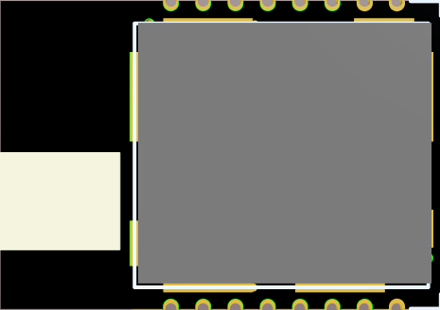

**30MM**

**UWB**

**21MM**

# 2 Module hardware description

## 2.1 Module hardware pin definition

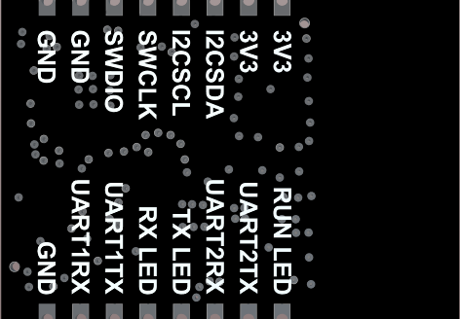

**16MM**

**15MM**

**14MM**

**13MM**

**12MM**

**11**

**100MM**

**90MM**

**10MM**

**20MM**

**30MM**

**40MM**

**50MM**

**60MM**

**70MM**

**80MM**

|  |  |  |
| --- | --- | --- |
| **Index** | **Pin** | **Function** |
| 1 | 3V3 | Power 3.3v |
| 2 | 3V3 | Power 3.3v |
| 3 | I2CSDA | Reserve pin(NC) |
| 4 | I2CSCL | Reserve pin(NC) |
| 5 | SWCLK | Module download port |
| 6 | SWDIO | Module download port |
| 7 | GND | GND |
| 8 | GND | GND |
| 9 | RUN LED | Module running indicator,Anchor/Tag universal (except for Tag entering Sleep)  Configuration status: Blinking slowly (1 second)  Working status: Blinking at short intervals (0.1 seconds) |
| 10 | UART2 TX | Reserve pin(NC) |
| 11 | UART2 RX/RESET/WAKEUP | Function 1: Pull down 3 seconds reset (reset function)  Function 2: Tag low power state, pull down any time to wake up (wake up function, only valid Tag) |
| 12 | TX LED | Module UWB transmit indicator (Anchor valid,Tag invalid) |
| 13 | RX LED | Module UWB acceptance indicator (Anchor valid,Tag invalid) |
| 14 | UART1 TX | Module serial TX port |
| 15 | UART1 RX | Module serial RX port |
| 16 | GND | GND |

## 2.2 Module hardware package size

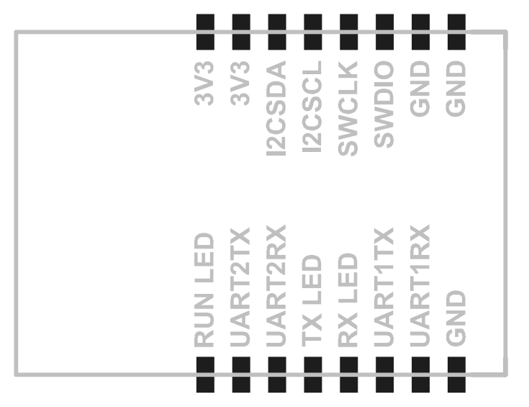

**2.2MM**

**30MM**

**1.1MM**

**2.2MM**

**3MM**

**21MM**

## 2.2 Power interface

|  |  |  |
| --- | --- | --- |
| **Index** | **Pin** | **Function** |
| 1 2 | 3V3 | Power supply 3.3V (Note: If the power supply voltage exceeds 3.3, the module will be damaged) |
| 7 8 16 | GND | GND |

lDO voltage regulator chip is used to increase 100UF tantalum capacitor and 100NF capacitor to stabilize voltage and reduce interference caused by power supply.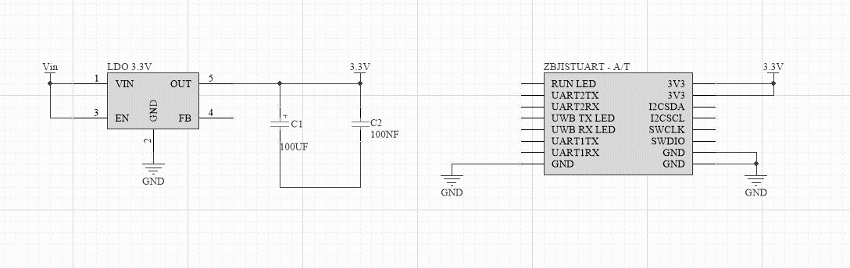

## 2.3 UART application circuit

|  |  |  |
| --- | --- | --- |
| **Index** | **Pin** | **Function** |
| 14 | UART1 TX | Moudle TX |
| 15 | UART1 RX | Module RX |

Serial port communication level is 3.3VTTL, different level systems should do level matching.

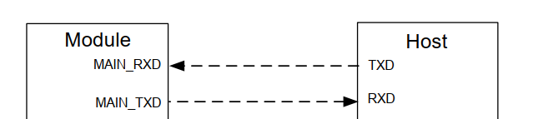

## 2.4 LED application circuit

|  |  |  |
| --- | --- | --- |
| **Index** | **Pin** | **Function** |
| 9 | RUN LED | Module running indicator,Anchor/Tag universal (except for Tag entering Sleep)  Configuration status: Blinking slowly (1 second)  Working status: Blinking at short intervals (0.1 seconds) |
| 12 | TX LED | Module UWB transmit indicator (Anchor valid,Tag invalid) |
| 13 | RX LED | Module UWB acceptance indicator (Anchor valid,Tag invalid) |

LED output High level LED is on, low level LED is off.

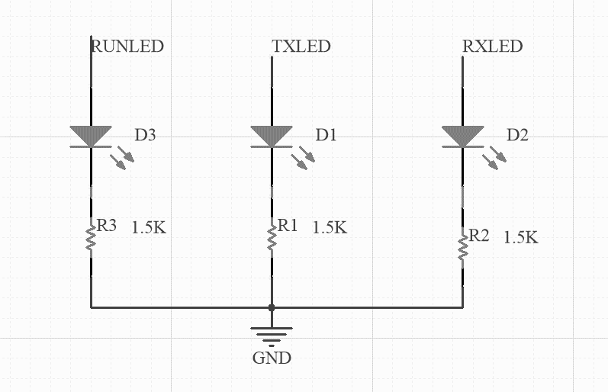

## 2.5 Reset interface

|  |  |  |
| --- | --- | --- |
| **Index** | **Pin** | **Function** |
| 11 | UART2 RX/RESET/WAKEUP | 1: Pull down 3 seconds reset (reset function)  2: Label low power state, pull down any time to wake up (wake up function, only valid label) |

It is recommended to use an open set or open drain drive circuit to control RESET.

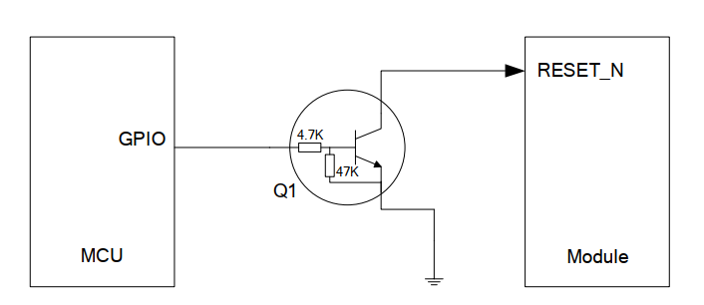

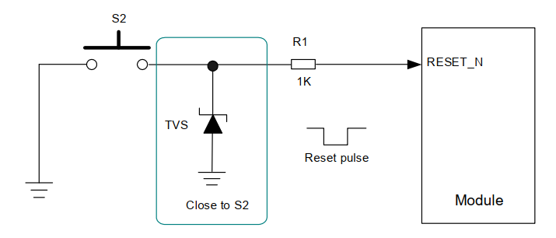

## 2.6 Download interface

|  |  |  |
| --- | --- | --- |
| **Index** | **Pin** | **Function** |
| 5 | SWCLK | Module download port |
| 6 | SWDIO | Module download port |

Firmware upgrades for hardware modules can be performed via ST-LINK.

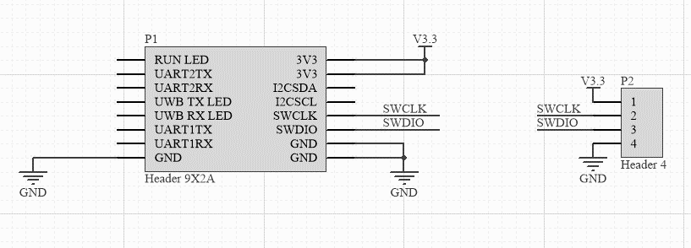

# 3 Description of the module AT command

## 3.1 Command summary description

|  |  |  |  |
| --- | --- | --- | --- |
| **Index** | **Command** | **Function** | **Role** |
| 1 | AT? | Serial port test | Tag/Anchor |
| 2 | AT+GETVER? | Get version | Tag/Anchor |
| 3 | AT+RESTART | Restart module | Tag/Anchor |
| 4 | AT+RESTORE | Restore configuration | Tag/Anchor |
| 5 | AT+SAVE | Save configuration | Tag/Anchor |
| 6 | AT+SETCFG | Set role message | Tag/Anchor |
| 7 | AT+GETCFG? | Get role message | Tag/Anchor |
| 8 | AT+SETANT | Set antenna delay | Tag/Anchor |
| 9 | AT+GETANT? | Get antenna delay | Tag/Anchor |
| 10 | AT+SETCAP | Set the Anchor/Tag capacity of the system | Tag/Anchor |
| 11 | AT+GETCAP? | Get the Anchor/Tag capacity of the system | Tag/Anchor |
| 12 | AT+SETRPT | Set the automatic reporting status | Tag/Anchor |
| 13 | AT+GETRPT? | Get the automatic reporting status | Tag/Anchor |
| 14 | AT+RANGE | Active reporting command | Tag/Anchor |
| 15 | AT+SLEEP | Sleep command | Tag |

## 3.2 Command：AT?

|  |  |
| --- | --- |
| Command | AT? |
| Parameter |  |
| Return |  |
| Example | AT?  OK |
| Function | Verify that the serial port communication of the module is normal |

## 3.3 Command：AT+GETVER?

|  |  |
| --- | --- |
| Command | AT+GETVER? |
| Parameter |  |
| Return | x1: indicates the software version  x2: Hardware version |
| Example | AT+GETVER?  AT+GETVER=software:v01_00_000,hardware:v01_03_000 |
| Function | Obtain the module software version and hardware version |

## 3.4 Command：AT+RESTART

|  |  |
| --- | --- |
| Command | AT+RESTART |
| Parameter |  |
| Return |  |
| Example | AT+RESTART  OK |
| Function | Reset module |

## 3.5 Command：AT+RESTORE

|  |  |
| --- | --- |
| Command | AT+RESTORE |
| Parameter |  |
| Return |  |
| Example | AT+RESTORE  OK |
| Function | Restore factory mode (clear all configuration information) |

## 3.6 Command：AT+SAVE

|  |  |
| --- | --- |
| Command | AT+SAVE |
| Parameter |  |
| Return |  |
| Example | AT+SAVE  OK |
| Function | Save the configuration parameters (after configuring the information, be sure to save and write to the flash) |

## 3.7 Command：AT+SETCFG

|  |  |
| --- | --- |
| Command | AT+SETCFG=(x1),(x2),(x3),(x4) |
| Parameter | x1:Device ID(Anchor 0-7，Tag 0-31)  x2:Device Role(0:Tag / 1:Anchor)  x3:Equipment communication rate(0:850K/1:6.8M，Default:6.8M)  x4:Range filtering is enabled(0:Close / 1:Open) |
| Return |  |
| Example | AT+SETCFG=0,1,1,1  OK |
| Function | Set basic module parameters |

## 3.8 Command：AT+GETCFG?

|  |  |
| --- | --- |
| Command |  |
| Parameter |  |
| Return | x1:Device ID(Anchor 0-7，Tag 0-31)  x2:Device Role(0:Tag / 1:Anchor)  x3:Equipment communication rate(0:850K/1:6.8M，Default:6.8M)  x4:Range filtering is enabled(0:Close / 1:Open) |
| Example | AT+GETCFG?  AT+GETCFG=0,0,1,1 |
| Function | Obtain basic module parameters |

## 3.9 Command：AT+SETANT

|  |  |
| --- | --- |
| Command | AT+SETANT=(x1) |
| Parameter | x1:Device antenna delay |
| Return |  |
| Example | AT+SETANT=16536  OK |
| Function | Set module antenna delay (antenna delay is used to: calibrate distance values) |

## 3.10 Command：AT+GETANT?

|  |  |
| --- | --- |
| Command | AT+GETANT? |
| Parameter |  |
| Return | x1:Device antenna delay |
| Example | AT+GETANT?  AT+GETANT=16536 |
| Function | Get module antenna delay (antenna delay for: calibrating distance values) |

## 3.11 Command：AT+SETCAP

|  |  |
| --- | --- |
| Command | AT+SETCAP=(x1),(x2) |
| Parameter | x1:Tag capacity (default: 10, maximum: 64)  x2: Time of a single time slot (6.8M not less than 10ms,850K not less than 15ms)  (Note: The refresh rate relationship is as follows: label capacity x single slot time,  Example 1: If x1=10 and x2=10, the refresh rate is 10Hz  Example 2: If x1=5 and x2=10, the refresh rate is 20Hz  Example 3: x1=1 x2=10, then refresh rate = 100Hz) |
| Return |  |
| Example | AT+SETCAP=10,10  OK |
| Function | Set system base station/label capacity (refresh rate) |

## 3.12 Command：AT+GETCAP?

|  |  |
| --- | --- |
| Command | AT+GETCAP? |
| Parameter |  |
| Return | x1:Tag capacity (default: 10, maximum: 64)  x2: Time of a single time slot (6.8M not less than 10ms,850K not less than 15ms)  (Note: The refresh rate relationship is as follows: label capacity x single slot time,  Example 1: If x1=10 and x2=10, the refresh rate is 10Hz  Example 2: If x1=5 and x2=10, the refresh rate is 20Hz  Example 3: x1=1 x2=10, then refresh rate = 100Hz) |
| Example | AT+GETCAP?  AT+GETCAP=10,10 |
| Function | Get system base station/label capacity (refresh rate) |

## 3.13 Command：AT+SETRPT

|  |  |
| --- | --- |
| Command | AT+SETRPT=(x1) |
| Parameter | x1: Whether the report is reported automatically (0: off 1: on) |
| Return |  |
| Example | AT+SETRPT=1  OK |
| Function | Enable whether the module actively reports distance data. |

## 3.14 Command：AT+GETRPT?

|  |  |
| --- | --- |
| Command | AT+GETRPT? |
| Parameter | x1: Whether the report is reported automatically (0: off 1: on) |
| Return |  |
| Example | AT+GETRPT?  AT+GETRPT=1 |
| Function | Enable whether the module actively reports distance data. |

## 3.15 Command：AT+RANGE

|  |  |
| --- | --- |
| Command | AT+RANGE=tid:x1,mask:x2,seq:x3,range:(x4,x5,x6,x7,x8,x9,x10,x11),  rssi:(x12,x13,x14,x15,x16,x17,x18,x19) |
| Parameter |  |
| Return | tid:x1(Tag ID, in decimal format)  mask:x2(Significance bit, in hexadecimal format)  seq:x3(Tag communication sequence, in decimal format)  range0:x4(The distance from Tag to Abchor0 ,in cm, in decimal format)  range1:x5(Tag to Anchor 1)  range2:x6(Tag to Anchor 2)  range3:x7(Tag to Anchor 3)  range4:x8(Tag to Anchor 4)  range5:x9(Tag to Anchor 5)  range6:x10(Tag to Anchor 6)  range7:x11(Tag to Anchor 7)  rssi0:x12(Signal strength value from Tag to Anchor 0, in dBm, floating point type)  rssi1:x13(Signal strength value from Tag to Anchor 1)  rssi2:x14(Signal strength value from Tag to Anchor 2)  rssi3:x15(Signal strength value from Tag to Anchor 3)  rssi4:x16(Signal strength value from Tag to Anchor 4)  rssi5:x17(Signal strength value from Tag to Anchor 5)  rssi6:x18(Signal strength value from Tag to Anchor 6)  rssi7:x19(Signal strength value from Tag to Anchor 7) |
| Example | AT+RANGE=tid:0,mask:80,seq:197,range:(0,0,0,0,0,0,0,0),  rssi:(0.00,0.00,0.00,0.00,0.00,0.00,0.00,0.00) |
| Function | After the 3.12 command is set, the distance value is actively reported (common to Tag and Anchor). |

## 3.16 Command：AT+SLEEP

|  |  |
| --- | --- |
| Command | AT+SLEEP=(x1) |
| Parameter | x1: Sleep time(Unit : ms)[Range: 0-65535,65535=Forever]  (Wake up mode: ① serial port wake up (send any data) ②UART2 RX drop-down wake up at any time) |
| Return | OK |
| Example | AT+SLEEP=1000  OK |
| Function | Set the device sleep time (valid for Tags only) |